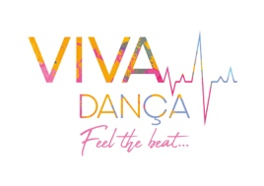
ROYAL BALLET SCHOOL’S INSPIRE PROFESSIONAL DEVELOPMENT PROGRAMME

Viva Dança Convention 2020 - Altice Forum Braga
6th June- Inspire Series 1- Seminar 1
7th June- Inspire Series 1- Seminar 2
10 am- 5 pm

Registration form
PLACES ARE LIMITED- PAYMENT MUST BE MADE TO RESERVE YOUR PLACE.

First Name: …………………………………… Last Name: ……………………………………

Address: ……………………………………………………………………………………………………………………

Email: ……………………………………………………………………………………………………………………

Telephone number: ……………………………………………………………………………………………………………………

Number of years teaching experience: ………………………………………………………

Inspire Seminar 1

Inspire Seminar 2

(€275 for one day/ €500 for both days)

Bank Details for payment:
Dreams Nectar- Associação
Millennium BCP
IBAN-PT50 0033 0000 4553240421405

Signature: ……………………………………………………………………………………………………………………
Once filled out please email to info@vivadancaconvention.com
There is an additional optional cost for course resources which can be purchased after submitting this form.

